Northampton County Medical Society Alliance
Casino Night
February 23, 2018

Place a bet on us to win big!

Support the 8th bi-annual Northampton County Medical Society Alliance Casino Night!

The NCMSA is a volunteer group of physicians and physicians’ spouses dedicated to
giving back to the community through a number of outreach programs and health initiatives.
This year’s Casino Night will raise funds for our grant program:
H.E.L.P. – Health, Education and Literacy Programs.

Since inception, our bi-annual Casino Night events have raised over $85,000 for local grants.
Most recently, the Alliance has funded a pilot program to teach mindfulness in a local elementary school; worked with the Children’s Home of Easton to integrate garden fresh produce into educational programs addressing childhood obesity; supported the YWCA Bethlehem Creative Aging Program for Seniors; and provided a grant to create programs on cyber safety, healthy relationships and mental health in a local school district. We have also supported a variety of community programs run by Meals on Wheels of Northampton County, Pennsylvania Youth Theatre, Boys and Girls Club of Bethlehem, New Bethany Ministries, Truth for Women, St. Luke’s,The Weller Center and Community Services for Children.

NCMSA’s Casino Night will be an exciting night attended by 200 prominent members of the Lehigh Valley medical community including St. Luke’s University Health Network, Lehigh Valley Hospital, Easton Hospital, Coordinated Health, and many independent practices.

Please consider being a part of this worthwhile event by becoming a sponsor. Casino Night will be held on Friday, February 23, 2018 at DeSales University. There will be “funny” money gambling, music, food, open bar, prizes, raffles and more!

Thank you for your consideration!

Sincerely,
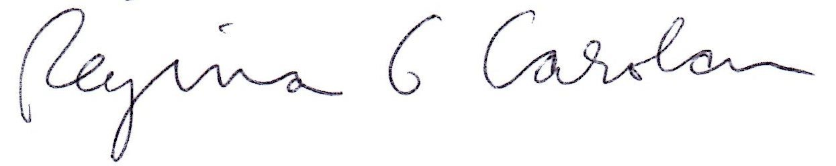
Regina Carolan
NCMSA President
856-220-6081
medsocietyalliance@gmail.com

President
Regina Carolan

Vice-President
Shannon McGinley Jaindl, DPM

Treasurer
Lisa Amortegui

Event Co-Chairs
Virginia Oskin
Ashley Russo

Committee
Teri Ahmad
Sarina Ashford
Kimberly Bedrosian
Julia Burfeind
Fran Fisher
Colleen Fitzpatrick, MD
Trinette Hernandez
Maria Kriner
Christine Mira
Lisa Pristas, DO
Karen Psaila
Lauren Rabin
Stephanie Schleef
Helen Snyder
Sue Tallick, MD
Jamie Taylor
Stefanie Traub
Ann Marie Zaladonis
Catherine Zarrelli

www.ncmsa.org

Northampton County Medical Society Alliance
Casino Night
February 23, 2018

SPONSORSHIP LEVELS

BLACK CHIP $5,000
Presenting Sponsor
Entrance Signage
Gaming table signage
5 Advertisements rotating on big screen
Ten tickets to the event

GREEN CHIP $2,500
Gaming table signage
3 Advertisements rotating on big screen
Six tickets to the event

RED CHIP $1,000
Food table Signage
2 Advertisements rotating on big screen
Four tickets to the event

BLUE CHIP $ 500
1 Advertisement rotating on big screen
Two tickets to the event

HIGH ROLLER $ 250
1 Advertisement rotating on big screen

*All levels include recognition via Thank You ad in local newspaper*

NCMSA is a non-profit 501(c)3 organization.
Thank you for your support!

Northampton County Medical Society Alliance
Casino Night
February 23, 2018

SPONSOR INFORMATION

Name of Organization:______________________________________________

Contact Person:_____________________________________ (or attach business card)
Title: __________________________________________
Address: __________________________________________
__________________________________________
Phone: __________________________________________
E-mail: __________________________________________

Sponsorship Level:

____ Black Chip ($5000)
____ Green Chip ($2500)
____ Red Chip ($1000)
____ Blue Chip ($500)
____ High Roller ($250)

Enclosed is a check made payable to “NCMSA” in the sum of $____________

Please indicate exactly how you wish to be listed in event materials:

_________________________________________________________________________

Sponsor Material Checklist: We prefer to receive your information in an e-mail attachment.
A print out is also helpful for matching the final product.

_____ Sponsor advertisement(s) for rotation on big screen
Ads can be the same or different. These will be input into PowerPoint.
_____ Sponsor Logo -- for Posters and signage. Please send logo versions in color and black and white.

A copy of this form, a check and your print ready materials should be sent to: Deadline is 2/5/18

Lisa Amortegui
NCMSA Treasurer
2030 Rainlilly Dr
Center Valley, ‎ PA‎ 18034
865-712-5849 or lisarenee143@yahoo.com
e-mail: medsocietyalliance@gmail.com
NCMSA is a non-profit 501(c)3 organization. Thank you for your support!

